DCC club report 2023 for CC AGM
Weekly sessions at Barrow Docks and Barrow swimming pool have continued throughout the year.
Pool numbers have not yet risen to pre-pandemic numbers. Alternate pool sessions are used for polo training.
The dock sessions have been well attended by regulars and new members. In addition to club members many other groups have attended sessions during weekdays with over 100 gaining their BC Start awards. Pupils from a local junior school’s consortium attended weekly term time sessions from April to October.
An open day during the festival of the sea weekend attracted over 100 people and hosted a Cumbria clubs polo comp.
Monthly family days on lake and or canal ran throughout the year.
Very few river trips took place.
Competition:-
Club members attended 10 Marathon events during the year including the national Finals in September. 28 members entered 1 or more race.
DCC organized 3 WWR events – see CC race report.
Polo Report by Michelle Sanderson :-
Fortnightly pool session every Thursday for all...
Summer months dock sessions 10yrs and above ( will be back next year, will need advertise more)
We also held session's for scouts, clubs, police cadets as single end of season session's.
Weekly session's for sea cadets who went on to play other sea cadets around the North West..( came 3rd)
Duddon canoe club have held one Cumbria tournament attended by members from Duddon, Lakeland and Penrith this was in-line with the festival of the sea..
We also held a local tournament where we invited the sea cadets back and had 2 Duddon teams this was in line of Orsted officially handing over 3 brand new polo boats sponsored fully by them...
We have had 2 ladies spend an evening training with Penrith to try their boats so they could progress to play in the ladies nationals at Nottingham and are keen to carry on playing for the ladies team, hopefully we will get more.
2 youths and 2 adults attended a training day at Killington put on by Penrith this was enjoyed,
From this we have had one youth play with Penrith youth team at Liverpool as well as one male adult these are also keen to progress...
Helmet face guards have been upgraded, one floating goal has been hand made by a club member and a grant has been asked for from British canoe polo so we can renew our court as its well needed and have a spare to swap them over when we are cleaning it off.

We have a number of members who attended polo sessions regularly, we are keen to help others try out the sport.
Thanks go out to all the support from Penrith to help us progress from local tournaments to nationals , hopefully we can get some more local ones to get more interested.
Social:-
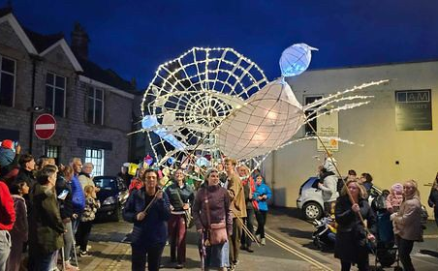
DCC again made a massive lantern to lead a section of the Ulverston lantern parade.

A Halloween paddle and bonfire was organised for regular docks attendees.

