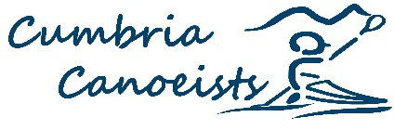
Youth River Running Report 2021/22

For the 2021-2022 Winter Season, and now again for the 2022-2023 Winter Season; the Youth River running group has split to run two differentiated Groups – due to range of abilities and numbers.

The “General” group is aimed at those either new to the initiative or those working on their intermediate river paddling skills; building confidence and practicing core techniques.

There is also an Advanced group for those with some more experience.
The General group has been working on Grade 2 with occasional short sections of Grade 3, with the Advanced Group working at Grade 3 with occasional grade 4 sections.

Both groups work on personal boat handling, river reading skills and all aspects of River Safety; working towards accredited awards.

Attendance is generally consistent; with each session attracting between five and eight Youth Paddlers, with one or two coaches and potentially one to four other Adults; either as Parents learning themselves – or as guest coaches!

Rivers paddled over the last 12 months include Eden, Greta, Lune, Tryweryn, Tees, Leven & Nith with paddlers from the group also off paddling the Calder, Irthing & Crake with their respective clubs.

The Group continues to expand – with a mailing list of circa 50 people linked to the group; either as participants or supportive coaches who help out when available. We are constantly trying to publicise the initiative! A short video of the Youth group exploits was shown at the Lakeland Canoeing Film Festival in October – and the full video will be on screen during the break.

If you have a Youth that has some basic Whitewater skills – and would like to come and paddle with other like-minded youths – then please reach out to me!

Mike Fletcher
cumbriacanoeistscommunication@gmail.com

